**A REPORT ON ASSIGNMENT 3**

FSIS Software

**Student : Nguyen Thi Ngoc Anh**

**Class : 8C-18**

**Student ID : 1801040015**

**Course : Software Engineering**

**Date : December 4, 2020**

**Design Note**

**1.**

* Java Comparable interface is used to order the objects of the user-defined class.

This interface contains one method named compareTo(Object) method to compare the current object with the specified object. In this assignment, it is aimed to compare two objects Customer and HighEarner for order.

Without using Comparable, you can use a compatible instance of Comparator instead. Comparable is for classes which have a notion of natural ordering. Nevertheless, increasing the responsibility of Object class for a requirement very specific is not a good idea either. The interface is thus of utmost importance for the compiler (type-checking) and for the runtime performance.

Furthermore, the interface is a strong indication that the compareTo() method was implemented on purpose to compare instances of that class, and not just a method that happened to have that exact signature but was doing something entirely different. Comparable interface makes things more clear that it is executed to compare two Customer objects and help SortedSet to compare its stored objects.

* Document interface defines a structural piece of Document, like a paragraph , a line of text, or a list item in an HTML document. Therefore, Customer and HighEarner objects can be read as HTML documents by looking for keywords in the search engine.

Without using Document, you can use another way of designing the same functionality such as using toHtmlDoc() method. Customer class implements interface Document, it can return a String containing the text of a simple HTML document, its objects can be read as HTML documents by the keyword search engine.

**2.**

HighEarner objects saved, inherit attributes and methods which have been declared in Customer already, can be reused in other programs.

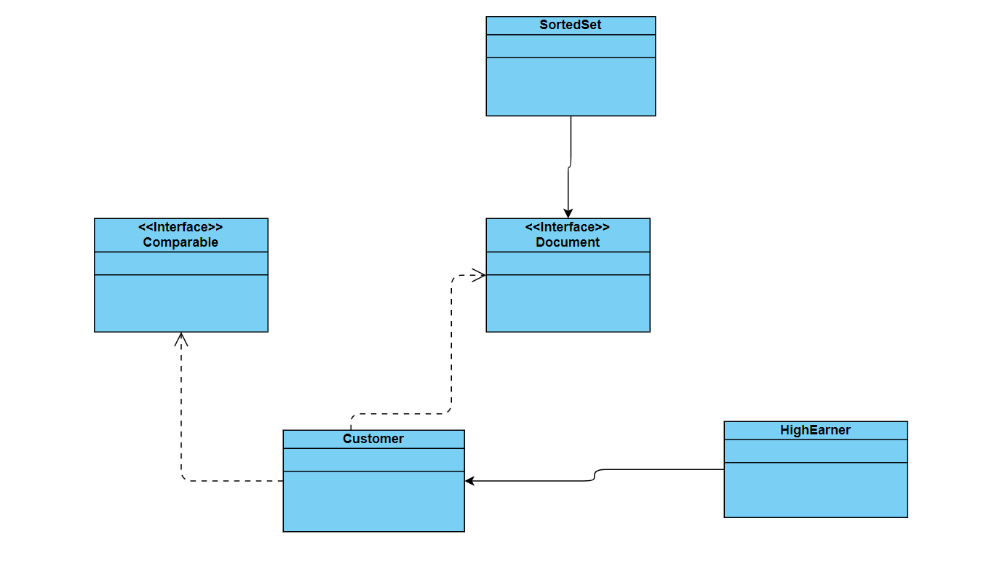

**3.**

Using the SortedSet class in the software to list Customer or HighEarner objects and order them following to notion of natural ordering(their name).

Without using this clas, it is not impossible to develop the same software functionality, for things like Collections.sort and TreeSet, HashSet for objects, those aren't hardcoded for a specific type, but they have to be able to call compareTo on the objects you pass it to. implementing Comparable means that TreeSet, HashSet know that the objects you pass them will have that method to be called.

**4.**

toHtmlDoc() method (interface Document) called in the Customer class to return a String containing the text of a simple HTML document, search for Customer objects using keywords. KEngine ordered documents of the stored Customer objects.

**5.**

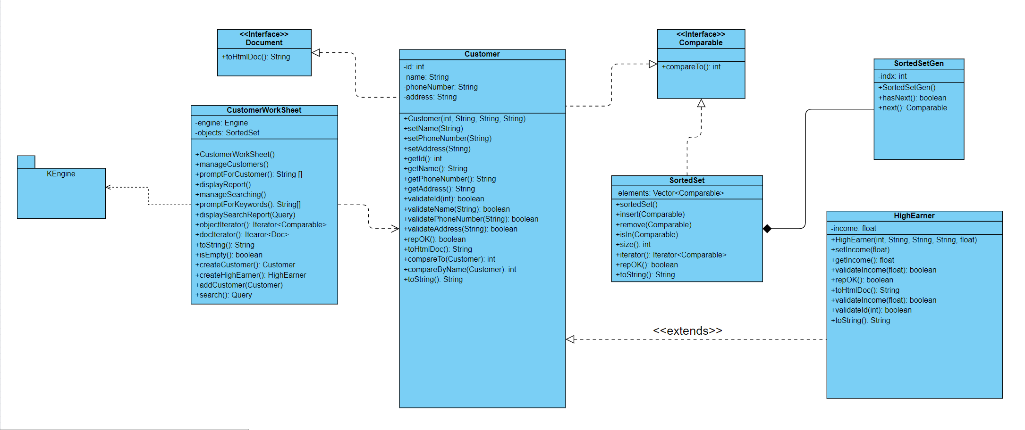

**6.**

You can implement Top-Down strategy: Top down, is a traditional strategy that works from the top of the organization down. It is one of the oldest and most established strategies. Top-down investing strategies typically focus on exploiting opportunities, encompasses a vast universe of macro variables that follow market cycles while bottom-up approaches are more fundamental in nature.

Top-down analysis generally refers to using comprehensive factors as a basis for decision making. The top-down approach seeks to identify the big picture and all of its components. These components are usually the driving force for the end goal.

Top-down is commonly associated with the word "macro" or macroeconomics. Macroeconomics itself is an area of economics that looks at the biggest factors affecting the economy as a whole. These factors often include things like the federal funds rate, unemployment rates, global and country-specific gross domestic product, and inflation rates.

An analyst seeking a top-down perspective wants to look at how systematic factors affect an outcome. In corporate finance, this can mean understanding how big picture trends are affecting the entire industry. In budgeting, goal setting, and forecasting, the same concept can also apply to understand and manage the macro factors.

According to supporters of this approach, comprehension resides in the reader. The reader uses background knowledge, expectations, assumptions, and questions and engages in pre-reading strategies, such as previewing the text, predicting, and activating background knowledge.